Counter Summary

Path : Reports >> Category Summary.

Steps to reach Category Summary:
Step 1 : Reports in Steps to reach Category Summary : Open the Reports module from the Billing Application(POS).
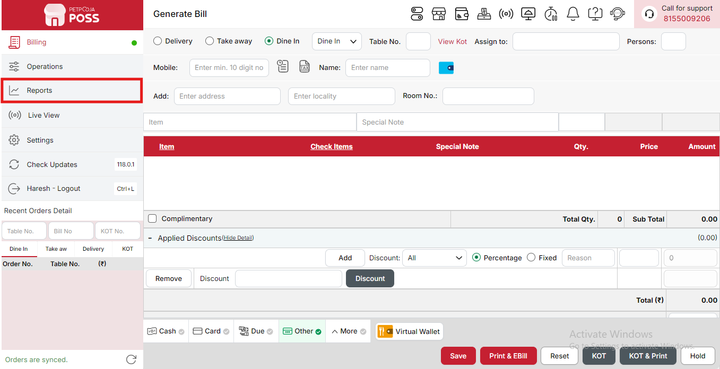
{Image Name: Reports Option,
Description: The red box highlights the “Reports” option in the sidebar menu. This section allows users to view and analyze various business reports, such as sales, billing, and order summaries, helping in effective tracking and decision-making.Here is an image of Step 1 Report in Steps to Reach Counter Summary.}
Step 2 : Category Summary in Steps to reach Category Summary : Select Category Summary to view detailed sales and performance information for each item category, including total quantity sold and total revenue generated.

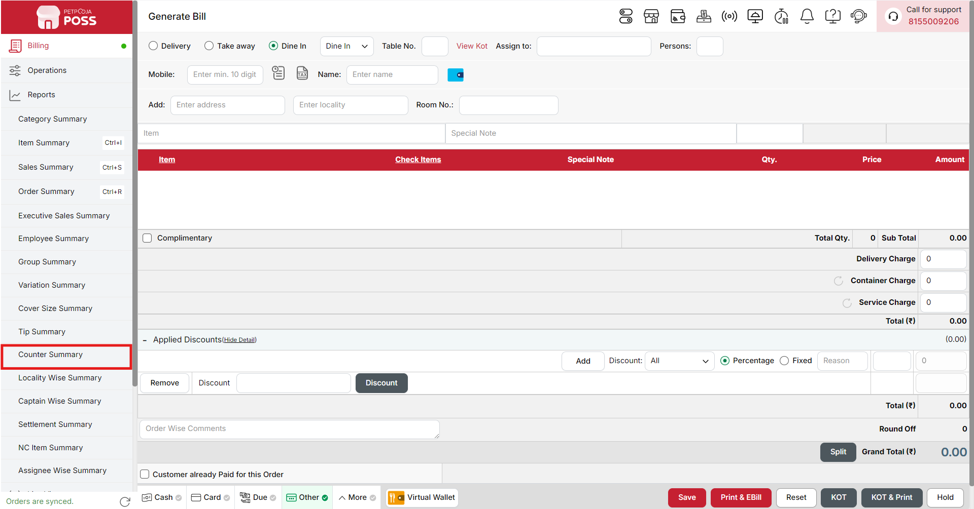
{Image Name: Counter Summary,
Description: The red box highlights the Counter Summary option under the Reports section. This feature provides a detailed overview of sales and transactions handled at each billing counter, helping monitor performance, reconcile cash, and ensure accurate counter-wise reporting.Here is an image of Step 2 Counter Summary in Steps to Reach Counter Summary.}

Key features of Counter Summary :
(Counter Summary) Note: If you are not able to see or use the Counter Summary option in your billing application, it means that you do not have the required permission. To enable this, you need to go to the Owner Dashboard and open the User Management section. Inside User Management, you will find a permission called Counter Summary Show Button — you must checkmark this option to give access.If you are not able to view old day reports, then you also need to enable the Days Restriction permission. Inside the same User Management section, select No Restriction so that you can view reports for any date.After allowing these permissions, perform a manual sync so the system updates the rights properly. Once the sync is done, log out from the billing application and then log in again. After this process, the Counter Summary option will become visible, and you will be able to view all reports without any problem.

- (Counter Summary) Counter Summary: Displays a complete overview of sales and order activity for each billing counter. This helps identify how much revenue each counter generated and how efficiently sales were handled throughout the day.
- (Counter Summary) Counter Name: Represents the name or type of billing counter (e.g., Billing Station, Captain, Master, etc.) where the orders were billed. This helps distinguish between different service or billing areas within the outlet.
- (Counter Summary) Complimentary Orders: Displays the total number of orders that were given free of cost, where no payment was collected. This helps track free or promotional orders issued during the day.
- (Counter Summary) Sales Return Orders: Shows the total count of orders that were returned or refunded after billing, helping track customer returns and refund activities.
- (Counter Summary) Cancelled Orders: Indicates the number of orders that were started but later canceled before completion. Monitoring this helps in understanding billing errors or customer cancellations.
- (Counter Summary) Success Orders: Displays the total number of successfully completed and billed orders for that counter, showing how many transactions were successfully processed.
- (Counter Summary) Net Amount (₹): Represents the total amount of sales after deducting discounts but before adding any applicable taxes. This shows the pure revenue generated from sales.
- (Counter Summary) Total Discount (₹): Displays the total discount value applied across all successful orders, including manual discounts, coupons, or offers.
- T(Counter Summary) Total Tax (₹): Represents the total amount of tax collected on all successful orders processed through that counter.
- (Counter Summary) Total Sales (₹): Displays the final billed amount after adding taxes and applying discounts. It represents the total sales revenue for that counter.
- (Counter Summary) Cash (₹): Shows the total cash collected from orders billed at that specific counter, helping track physical cash inflow.
- (Counter Summary) Card (₹): Displays the total amount received through card payments processed at the counter.
- (Counter Summary) Due Payment (₹): Indicates the total pending payment amount that is yet to be collected from customers for certain billed orders.
- (Counter Summary) Other (₹): Represents the amount received through other payment methods such as UPI, coupons, or digital wallets that do not fall under cash or card categories.
- (Counter Summary) Payment Mode Summary: Displays a breakdown of total collections based on different online and wallet payment methods. This helps in understanding the distribution of payments received digitally.
- (Counter Summary) Wallet (₹): Total amount received through digital wallet transactions such as Paytm, PhonePe, or other e-wallet services.
- (Counter Summary) Online Cash (₹): Amount received through online cash settlements or cash collected for online orders (e.g., COD reconciled transactions).
- (Counter Summary) Online Paid (₹): Total amount paid online by customers during ordering through digital payment methods such as credit/debit cards, UPI, or net banking.
Search Button (Counter Summary) : The Search button is used to find the report for a specific date or time. It helps you quickly see sales details for the selected period. After choosing the date or time, you can click on Search to view the report.
- From (Counter Summary) : The From option is used to select the starting date for the counter report. It means the report will begin from this date.
- To (Counter Summary) : The To option is used to select the ending date for the counter report. It means the report will show data up to this date.
- Time Wise Option (Counter Summary) : The Time Wise Option is used when you want to see the report for a specific time period within a day. After turning it ON, you can choose both date and time — for example, from 10:00 AM to 5:00 PM — to see sales during that time. If you keep this option OFF (Without Time Wise Option), then the report will show the whole day’s data for the selected date range without filtering by time.
Configure Column (Counter Summary) : Used to show or hide different columns in the report by checking or unchecking the boxes. If you want to see that option in the report, you have to check it, and if you want to hide it, you have to uncheck it.
- (Configure Column) Complimentary Orders: Shows the total number of complimentary (free) orders processed. You can check this to display it in the report or uncheck it to hide it.
- (Configure Column) Sales Return Orders: Shows the total number of sales return orders processed. You can check this to view return order details or uncheck it to hide them.
- (Configure Column) Cancelled Orders: Shows the total number of orders that were cancelled. You can check this to display cancellation details or uncheck it to hide them.
- (Configure Column) Success Orders: Shows the total number of successfully completed orders. You can check this to view it in the report or uncheck it to hide it.
- (Configure Column) Net Amount (₹): Shows the total amount received from sales before tax and after discounts. You can check this to view it in the report or uncheck it to hide it.
- (Configure Column) Total Discount (₹): Shows the total discount given across all orders. You can check this to show discount details or uncheck it to hide them.
- (Configure Column) Total Tax (₹): Shows the total tax amount added to all sales. You can check this to see tax details or uncheck it to hide them.
- (Configure Column) Total Sales (₹): Shows the final total sales amount after applying discounts and taxes. You can check this to display it in the report or uncheck it to hide it.
- (Configure Column) Cash (₹): Shows the total amount received through cash payments. You can check this to display cash transaction details or uncheck it to hide them.
- (Configure Column) Card (₹): Shows the total amount received through card payments. You can check this to display it in the report or uncheck it to hide it.
- (Configure Column) Due Payment (₹): Shows the total pending or due payment amount. You can check this to view due details or uncheck it to hide them.
- (Configure Column) Other (₹): Shows the total amount received through other payment methods. You can check this to include it in the report or uncheck it to hide it.
- (Configure Column) Wallet (₹): Shows the total amount received through wallet transactions. You can check this to display it in the report or uncheck it to hide it.
- (Configure Column) Online Cash (₹): Shows the total amount received through online cash payments. You can check this to display it in the report or uncheck it to hide it.
- (Configure Column) Online Paid (₹): Shows the total amount successfully paid online by customers. You can check this to display it in the report or uncheck it to hide it.
(Counter Summary) Print Button: The Print Button is used to print the report. If you want to take a printout of the report, you just need to click on the Print button.
If you get an error saying “Please assign one printer for report print”, then follow these steps:
- Go to Operation → Bill/KOT Print → Multiple Printer Settings.
- Select and edit one printer that you want to use for printing the report.
- In that printer setting, there is an option called “Use this printer for report print”.
- Check this box and save the setting.
After doing this, you will be able to print the report successfully using the selected printer.
(Counter Summary) Print Configuration: This section is used to set how your report will look when you print it. You can change the format, size, and what details to show on the printed page.
- (Print Configuration) Format Preference: Used to select the layout or design of the printed report.
- (Print Configuration) Show Bill Header: If you check this option, the header (top part with company or shop name) will appear on the print.
- (Print Configuration) Show Bill Footer: If you check this option, the footer (bottom part with notes or messages) will appear on the printed report.
- (Print Configuration) NONE: Select this option if you don’t want to apply any specific print format or layout. The report will print in the default basic format without additional formatting or sections.
- (Print Configuration) Display To Date on Print: If you check this option, the “To Date” of the report will be shown on the printed page.
- (Print Configuration) Display Time on Print: If you check this option, the time will be displayed on the print along with the date.
- (Print Configuration) Display Summary Box on Print: If you check this option, a summary box will appear at the end of the report showing total amounts and other summary details.
- (Print Configuration) Display Print Date & Time on Print: If you check this option, the date and time when the report was printed will appear on the print.
- (Print Configuration) Main Width: Used to set the width of the report on the printed page. For example, 500 means the report will be printed with that width size.
- (Print Configuration) Font Size: Used to set the text size of the printed report. You can increase or decrease it as needed.
- (Print Configuration) Cancel: Click this button to close the print configuration window without saving any changes.
- (Print Configuration) Save:Click this button to save all the changes you made in the print configuration settings.
(Counter Summary) Export Excel: If you want to download or save the report in Excel format, you have to click on the Export Excel button. This will create an Excel file of the report that you can open and use in Microsoft Excel.

